IBM Installation Manager installation - Installing on location /IBMIM/IBM { In my case }
Step 1 : unzip the Package of IBM Installation Manager.-->
unzip Install_Mgr_v1.6.2_Lnx_WASv8.5.5
Step 2 : give the permission -->
chmod -R 755 <Install_Mgr_v1.6.2_Lnx_WASv8.5.5>
Step 3: Use below command
./installc -acceptLicense -installationDirectory /IBMIM/IBM -record /IBMIM/install.xml -showProgress
Where,
installc --> Installation Utility.
-installationDirectory --> installation directory path.
-record --> response file.
-acceptLicense --> to acceptLicense of package.
-showProgress --> current installation progress
Screenshot:1
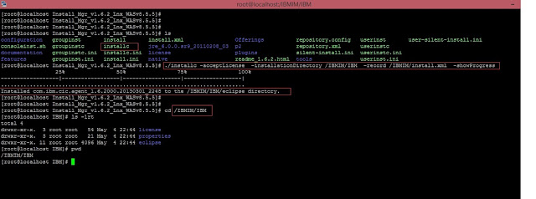
Step 4: go to installed location of Installation Manager /IBMIM/IBM {in my case}
Screenshot:2
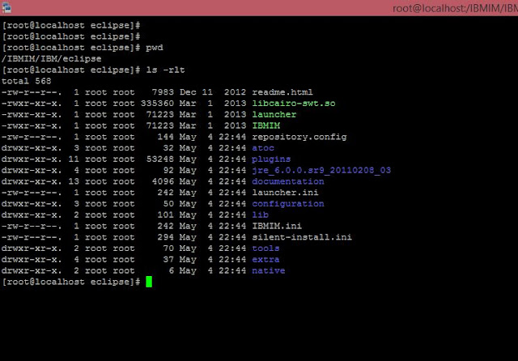
Step 5: unzip all the packges of WAS 8.5 1,2 and 3 in location
Screenshot:3
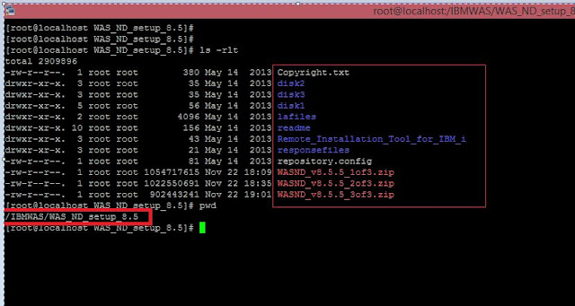
Step 6: Go to location /IBMIM/IBM/eclipse/tools {in my case } and use this command.
./imcl listAvailablePackages -repositories /IBMWAS/WAS_ND_setup_8.5
Where,
listAvailablePackages --> to check Package_ID verison
-repositories --> location of source repository
Screenshot:4
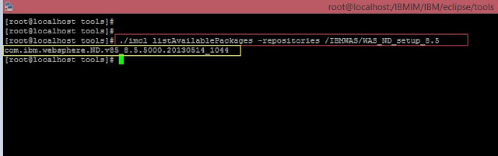
Step 7: Installation Of WebSphere Application server 8.5 on desired location.
./imcl install com.ibm.websphere.ND.v85_8.5.5000.20130514_1044 -acceptLicense -repositories /IBMWAS/WAS_ND_setup_8.5 -installationDirectory /IBMWAS/IBM -record /IBMWAS/response_WebSphereAppServer.xml -sP
Where,
-acceptLicense --> to acceptLicense of package.
-repositories --> location of source repository
-installationDirectory --> where we want to install WebSphere Application Server 8.5
-record --> to record response file.
-sP --> current installation progress
Screenshot:5
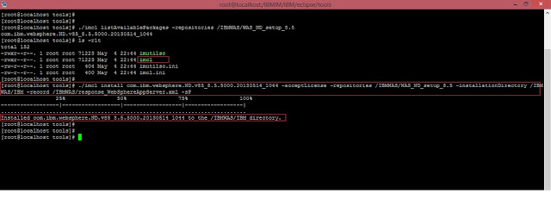
Installed WAS location :
Screenshot:6
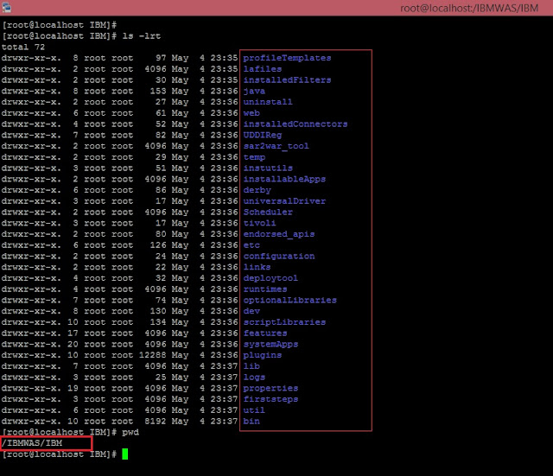
Step 8: Check Version of WAS through versionInfo.sh
Screenshot 7:
